KRZYŻÓWKA DLA DZIECI

Wpisz wyrazy i odczytaj hasło – powodzenia☺

|  |  |  |  |  |  |  |  |
| --- | --- | --- | --- | --- | --- | --- | --- |
| 1  2  3  4  5 |  | |  |  |  |  |  |
|  |  |  |  |  |  |  |
|  |  |  |  |  |  | |
|  |  |  |  |  |
|  |  |  |  |  |

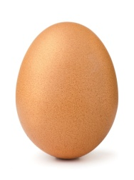

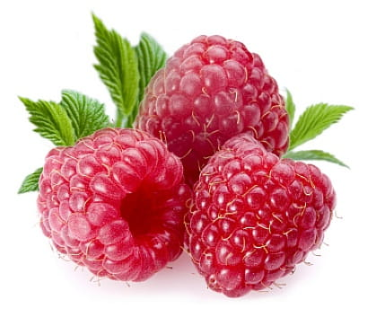1. 2. 3.

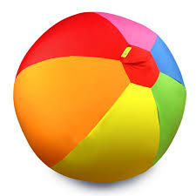4. 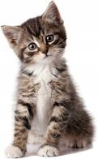 5.