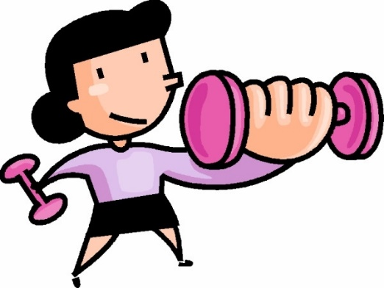

Five reasons to work out – a címet írd le a füzetedbe

Fill in the gaps with the words given – great, reasons, honest, motivation, difficult.
I’m sure we all know by now that exercise is ___________ for you. But let’s be ___________, sometimes finding that ___________ f to work out can be a little ___________ f. So, in this post, I am going to share my top five ___________ for working out.
- Exercise can completely change your mood!
Fill in the gaps with the words given – spinning class, run, work out, endorphins, happiness.
When you ___________, your body produces ___________, which will give you a rush of euphoria and ___________. You will feel better after a workout than you did before it. Next time you’re having a bad day, try going for a fast-paced ___________ or taking a ___________, and the day won’t seem so bad after all.
A fenti két bekezdést írd le a füzetedbe – idáig.
- Exercising is sociable. Translate the underlined words (fordítsd le az aláhúzott szavakat).
A füzetedbe csak a lefordított szavakat írd le.
Whenever I move to a new city to study or work, I look for exercise classes to do. You meet like-minded people, you can support each other during a difficult workout and you all share a collective feeling of euphoria when the class finishes!
- Exercise makes you feel confident. True or False? (Olvasd el az alábbi szöveget. Állapítsd meg, hogy az állítások igazak vagy hamisak).
A füzetedbe az állításokat írd le, és azt, hogy igaz vagy hamis.
We all know the physical effects of exercise on our bodies but we don’t always talk about the mental effects. Exercise might give you a feeling of confidence from being comfortable with your body and appearance. This new confidence might even help in your social or work life.
- The effects of exercise can be physical or mental. _____
- Exercise might not give you confidence. _____
- Exercise can make you comfortable with your appearance. _____
- It can help you only in your social life. _____

- It helps to relieve stress. Match the halves of the sentences. Kösd össze a szétválasztott mondatokat.
- can help you forget the problems and stress of daily life, studies or work.
- During exams, I always spend an ….
- It makes me feel less anxious and ….
b. hour a day in the gym.
- Focusing on lifting weights or going for a run ….
c. it also helps me to sleep those important eight hours the night before a big exam.

A füzetedbe az összekötött mondatokat írd le.

- Finally, exercise makes us feel strong, fit and healthy! Találd meg a szövegben és írd le a füzetedbe a következő szavakat angolul – súlyok, eredmény, kemény munka, sportcipő, izzadás.
Every day, the 20 minutes on the treadmill get easier, the weights feel lighter and you feel a great sense of achievement. It's a great feeling doing something you couldn’t do before and knowing it’s a result of your hard work.
So, next time you’re feeling down, put your trainers on and get sweating. It might not be easy but I promise you will feel so much better once you have finished!
Foglald össze saját szavaiddal a sportolás pozitív hatásait – 5-6 mondat elegendő, de kapcsolódjon az olvasott szöveghez.

