1 Przeczytaj i dopasuj. Read and match.
1 | He gets up at quarter to eight.  | 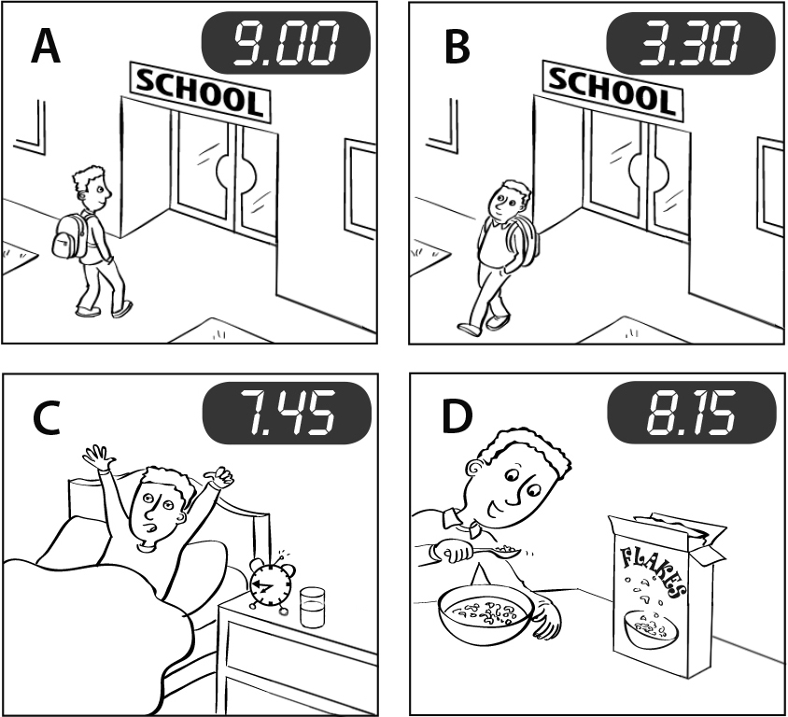
2 | He has breakfast at quarter past eight.
3 | He goes to school at nine o’clock.
4 | He goes home at half past three.
  4

2 Przeczytaj. Wybierz i uzupełnij tekst. Read. Choose and complete the text.
do watch get up have go
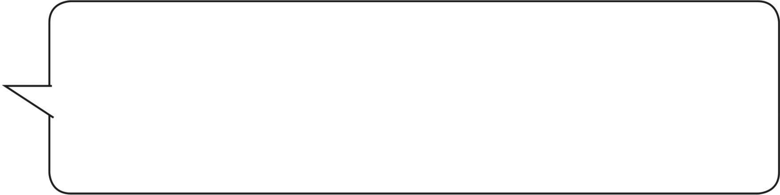
 | I 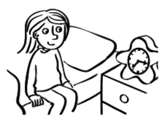 at 7.15.  and I 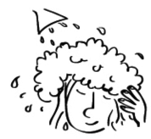 a shower at 7.30.

 | I 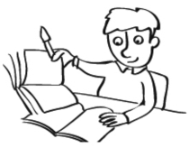 my homework at 6.45.  I 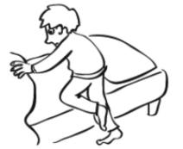 to bed at 9.15.
  4

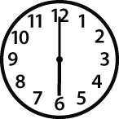
4 Popatrz i napisz. Look and write.
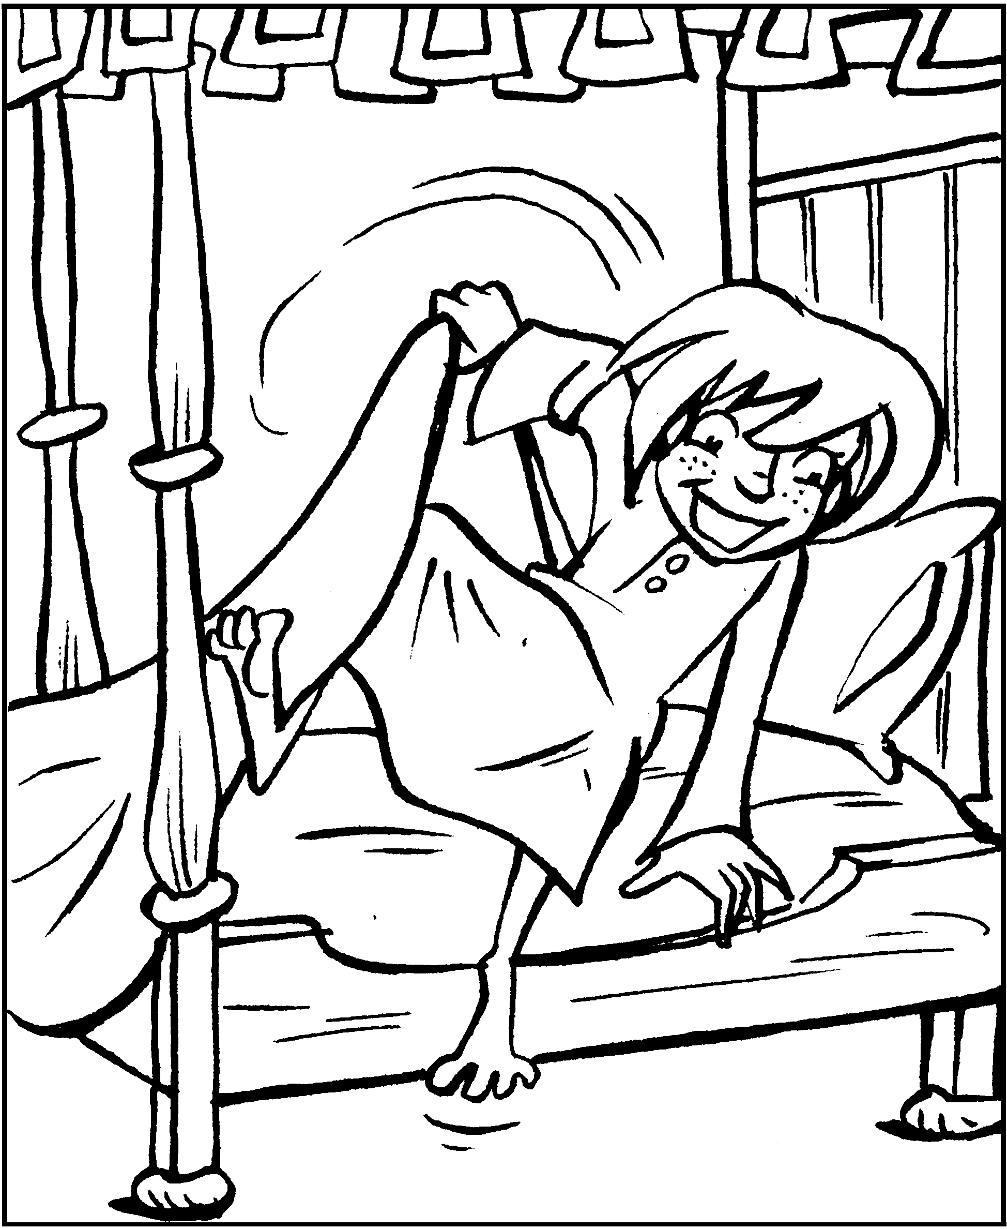  1 |  | 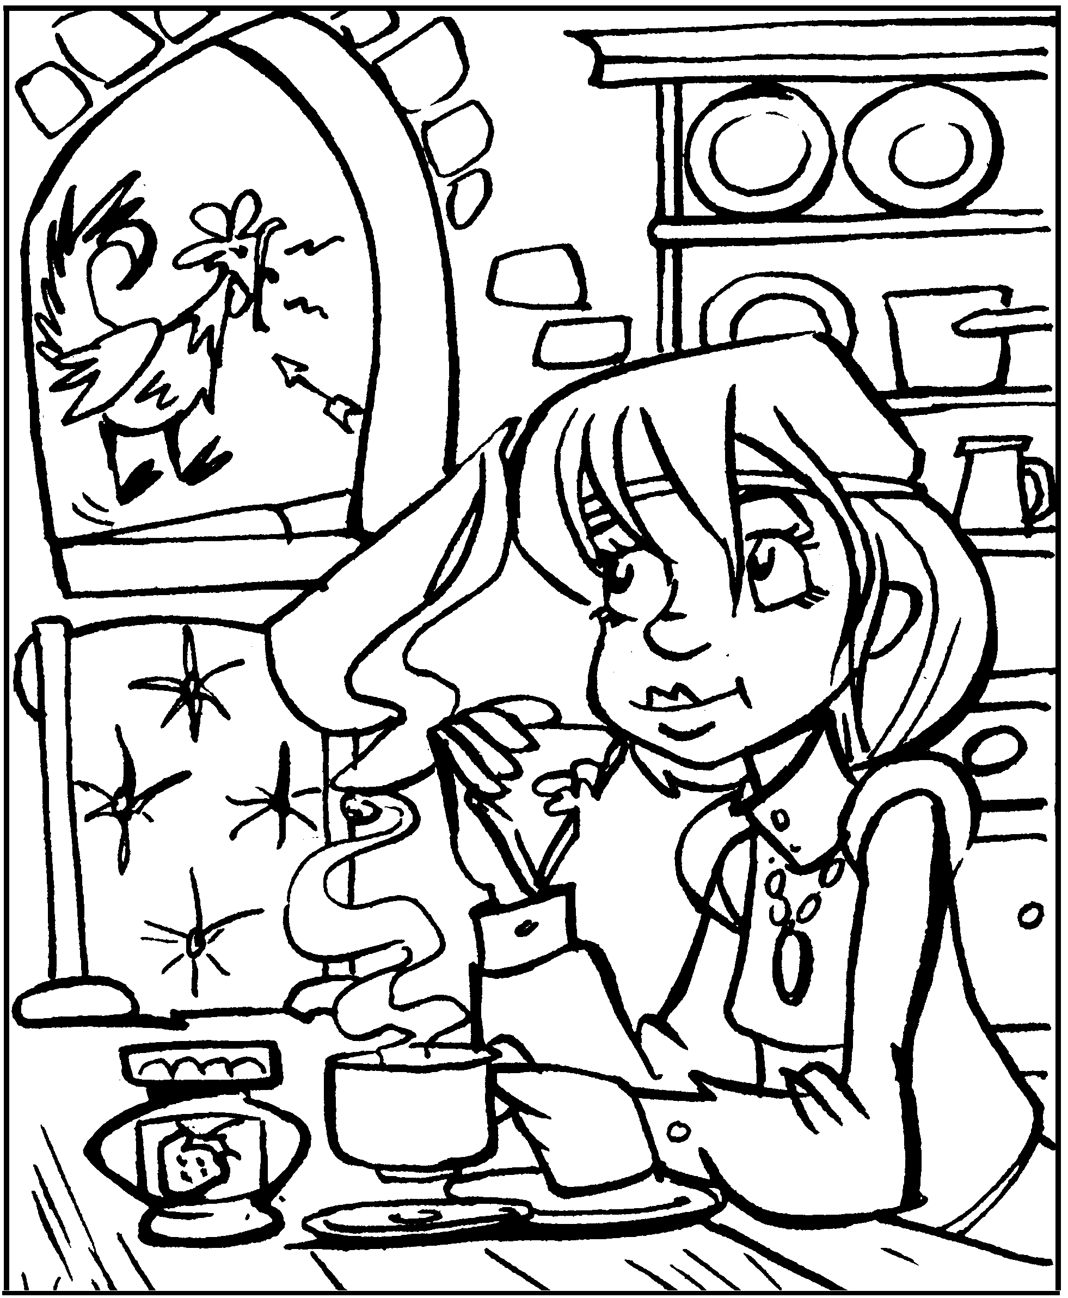  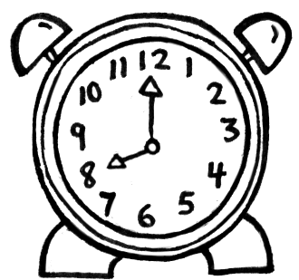  2
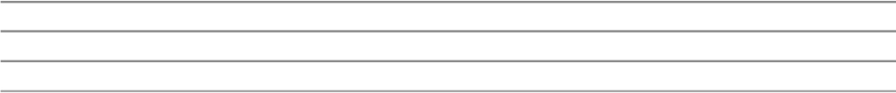
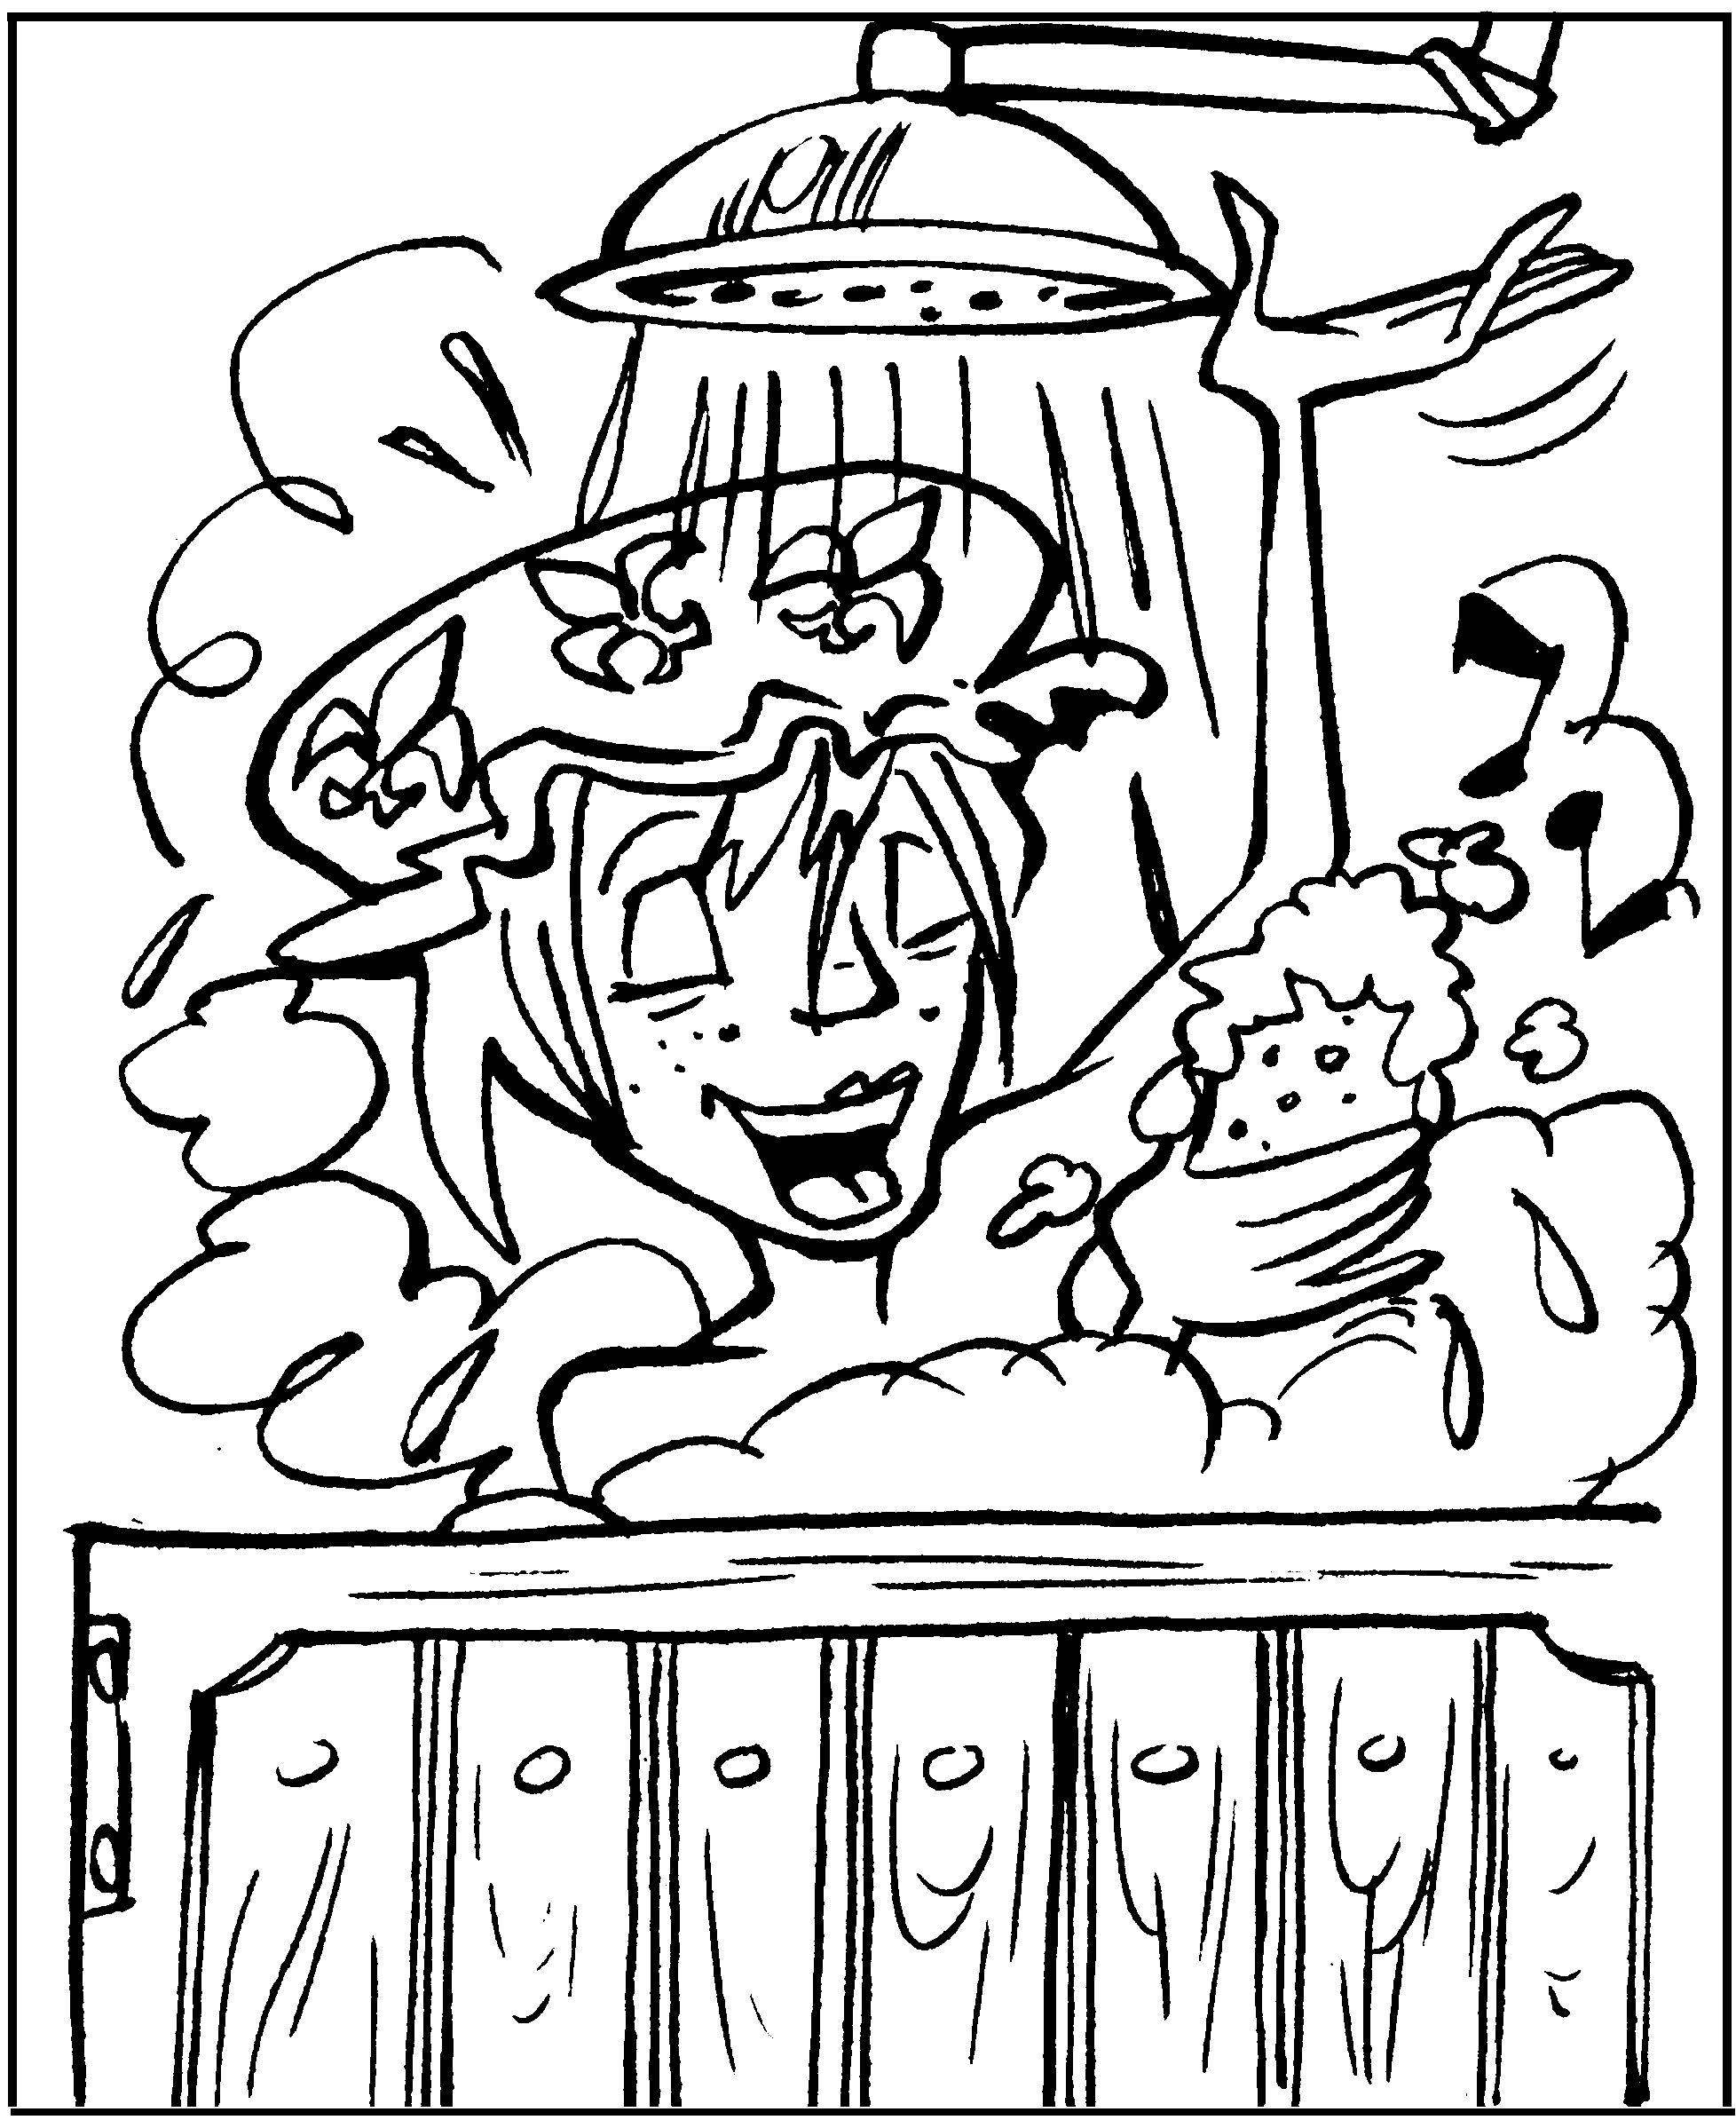  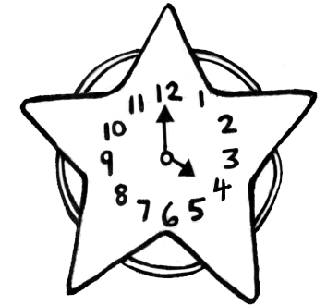  3 |  | 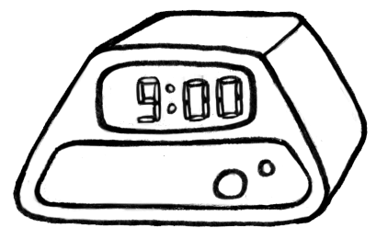  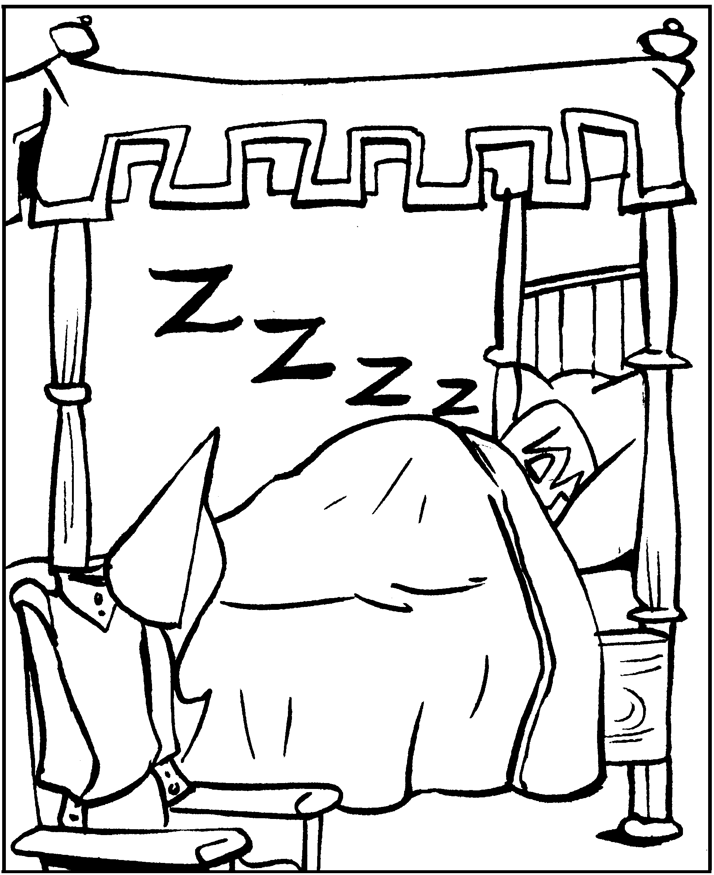  4
  4

5 Napisz pytania i odpowiedz na nie. Write the questions and answers.
1 What time do you ? I get up at .
2 ? I go to school at .
3 ? I have a shower at .
4 ? I go to bed at .
8

